Conversion of Camphene to Camphor (part 3)
Laura Kate Tharp
Tuesday, November 14, 2023
CHEM 2081-003

Introduction
In this experiment, borneol is added to sodium hypochloride and refluxed in a water bath to be converted to camphor.
Materials and Methods
In a long-neck 10 mL round-bottom flask, racemic 0.3 g of borneol product (from week 2) was added with 0.3 mL of glacial acetic acid, 1 mL of acetone, and a boiling chip. A reflux apparatus with the round bottom flask was set up over a warm water bath (40ºC-50 ºC), and the borneol was dissolved in the solution. Once dissolved, 6 mL of aqueous sodium hypochloride solution (bleach) was added to the flask dropwise over 35 minutes and swirled gently after each addition. After the last addition of sodium hypochloride, the solution was allowed to reflux for an additional 15 minutes. The mixture was cooled to room temperature before disassembling the reflux apparatus, and the camphor was extracted with two 2 mL portions of methylene chloride in a centrifuge tube. The methylene chloride layers were then neutralized with 2 mL of saturated sodium bicarbonate, and the acidity was tested using red litmus paper. The solution was the washed first with 2 mL of 5% sodium bisulfite and then 2 mL of water. The mixture was then dried with anhydrous sodium sulfate to ensure no microscopic water particles. The methylene chloride was evaporated off over a warm water bath (less than 50 ºC), and the collected product was weighed to determine yield.
Results
Weight of Watch Glass | 29.450 g
Weight of Watch Glass and Product | 29.616 g
Weight of Product | 0.166 g

Calculations
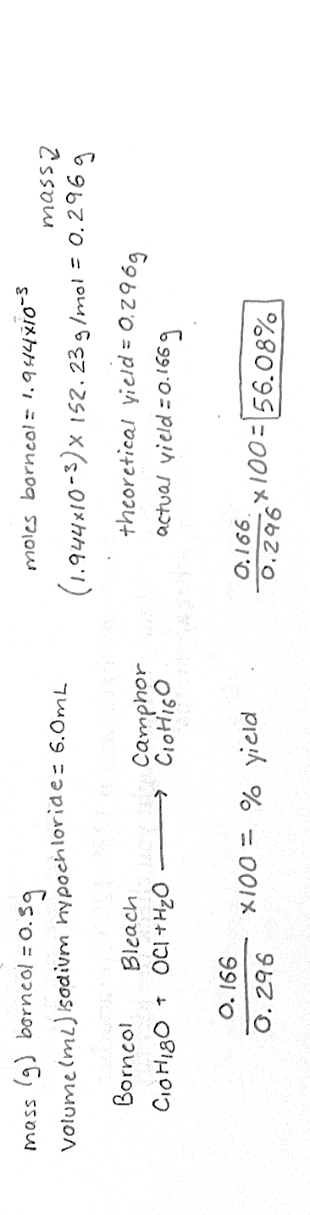
Discussion
In this experiment, camphor was produced via oxidation of borneol using sodium hypochloride. The result was camphor and methylene chloride, which was evaporated off to leave solid camphor. The product can be determined by its density, because methylene chloride has a density of 1.3 g/mL and water has a density of 1.0 g/mL, meaning that it will be the top layer. Additionally, the methylene chloride has a low boiling point of 39.6 ºC, and the warm water bath was at 50 ºC. Since the liquid product evaporated off and left only the solid product behind, it can be concluded that the remaining product was camphor, which has a melting point of 175 ºC. The cause for loss of product could be because of incomplete reaction during the reflux over the warm water bath, and the solution for this would be to use absorption spectroscopy to ensure that the reaction went to completion. Another source of error could be contaminated borneol, and the solution to this would be to test the melting point of a sample of the borneol prior to the experiment to ensure it was a pure sample.



